Screen Shot 1

- Welcome! Please pick the deck you would like us to use for your reading.

Note: Show the two decks as laid out above. The patterns should be visible (not the inside of the cards but the outside pattern).

Screen Shot 2 (I have changed the hierarchy of step 2 and 3). Go with this and not what it said on the rules and intro document.

Thank you. Take a deep breath and repeat sincerely:

- “Divine forces, please give me a clear reading of my life, and give me revelations that may help my journey.” Take a few moments to clear your mind and ask the universe about a situation at hand. If you would like a general reading………(next)

You have to pick 14 cards. Once you have picked all the cards, the interpretation will be given to you. You can pick the cards two ways:

Automatically pick my 14 cards for me

Lay my cards out so I can choose them myself

Screen Shot 3

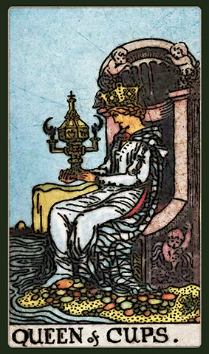

Screen Shot 5 (Note that Screen Shot 4 is to be provided by you—look up “BABELGUM ON ITUNES--TBD)

You’ve picked your 14 cards. Now, lets begin your reading! The Queen of Cups is relevant to your current situation or immediate concerns. The Queen of Cups is a lovely card in the deck to appear in a reading. The Queen of Cups is nurturing, spiritual, kind, gentle and benevolent. She may have strong psychic abilities as well. She is both intelligent and emotionally nurturing. The card may represent someone like this in your life, or it may represent you. If the card represents a situation, the result will be favorable—emotionally.

- SCREEN SHOT 6

- (Note if there are 8 to 9 major Arcana cards the screen shot would read, “ You’ve picked your 14 cards. Now, lets begin your reading. The cards you have chosen collectively reflect a strong karmic cycle. Meaning, what you are currently experiencing in your life will have far reaching implications, and will touch the very fabric of your being. There is little you can do to change your circumstances, but you can do much via attitude, and how you choose to react. The interesting thing about karmic phases is that sometimes they seem so innocent when you are experiencing them. The higher forces are at play. There are lessons you must learn. The majority of us don’t realize that this phase will change our lives forever. This is your journey and you must experience what is currently in store for you. There are difficult decisions ahead. You may experience emotional pain but these experiences will make you much wiser. Remember, the decisions you make today will have far-reaching implications. Deeper than you can imagine. This is a karmic lesson; therefore, the lessons will be profound and the impact will be powerful. This is a very important phase of your life. Believe in the power of the divine. Pray for strength, and be conscious that these experiences will teach you much. Remember, karma simply means that you get away with nothing. This implies to the people you are interacting with, and you. “

<SHOW QUEEN OF CUPS HERE>

The Queen of Cups is relevant to your current situation or immediate concerns. The Queen of Cups is a lovely card in the deck to appear in a reading. The Queen of Cups is nurturing, spiritual, kind, gentle and benevolent. She may have strong psychic abilities as well.

Before every interpretation, we have to show the image of the card. So for Card No. 2 you would show the card and then state:
“NAME OF CARD” is relevant to obstacles facing you currently, or things that are working for you currently.

